**NAME: Mahalakshmi S**

**ROLLNO: 205229118**

**SUBJECT: SMA LAB**

**Lab 15: Analysing Twitter Data using Neo4J**

**4. Explore the Cypher Query to create networks and table of frequency of the connections.**

// Table of Frequency of Connections followers

MATCH

(follower:User)-[:FOLLOWS]->(u:User:Me)

RETURN

follower.screen_name AS user, follower.followers AS followers

ORDER BY

followers DESC

**OUTPUT:**

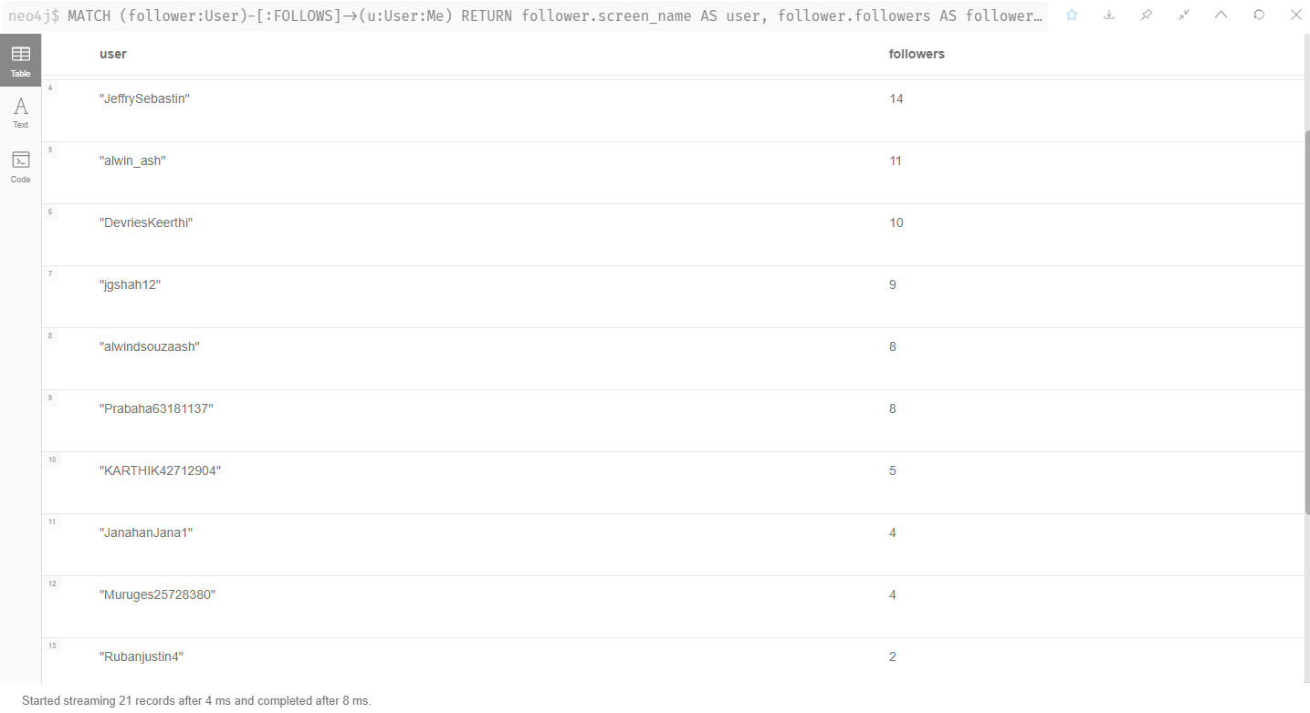

**5. Find the most influential followers from your connections.**

// Most influential followers

MATCH

(follower:User)-[:FOLLOWS]->(u:User:Me)

RETURN

follower.screen_name AS user, follower.followers AS followers

ORDER BY

followers DESC

LIMIT 10

**OUTPUT:**

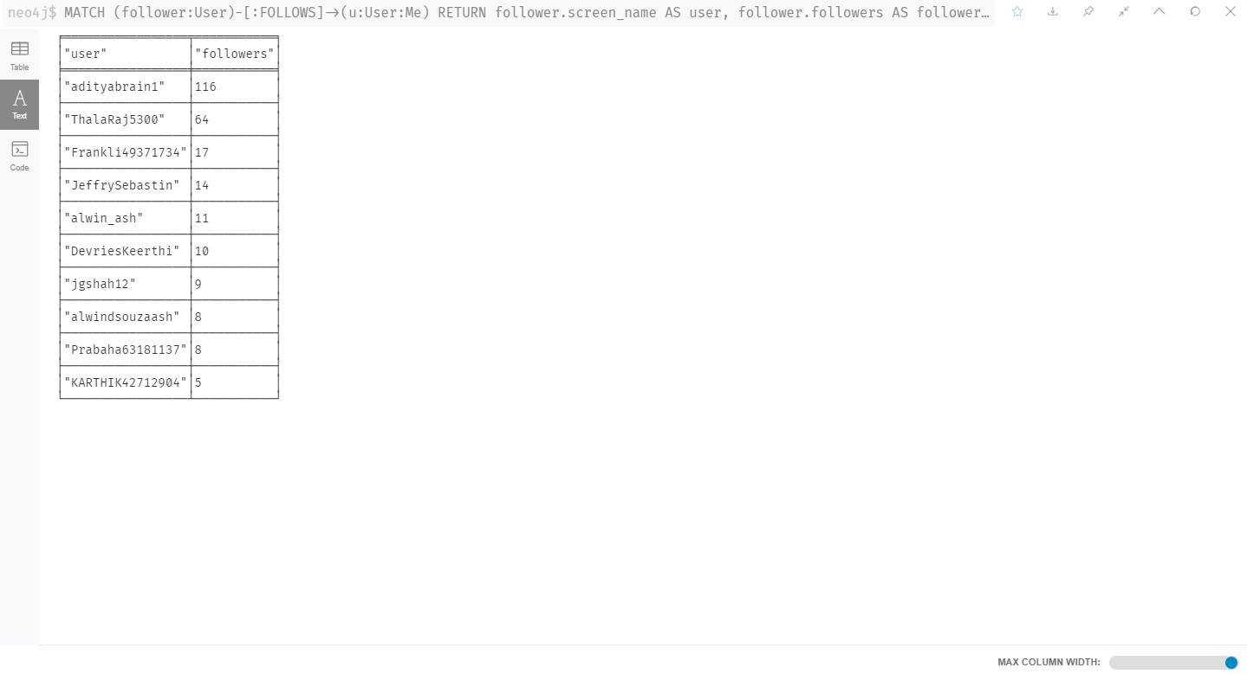

**6. Find the frequency of the most used hashtag.**

// The hashtags you have used most often

MATCH

(h:Hashtag)<-[:TAGS]-(t:Tweet)<-[:POSTS]-(u:User:Me)

WITH

h, COUNT(h) AS Hashtags

ORDER BY

Hashtags DESC

LIMIT 10

RETURN

h.name, Hashtags

**OUTPUT:**

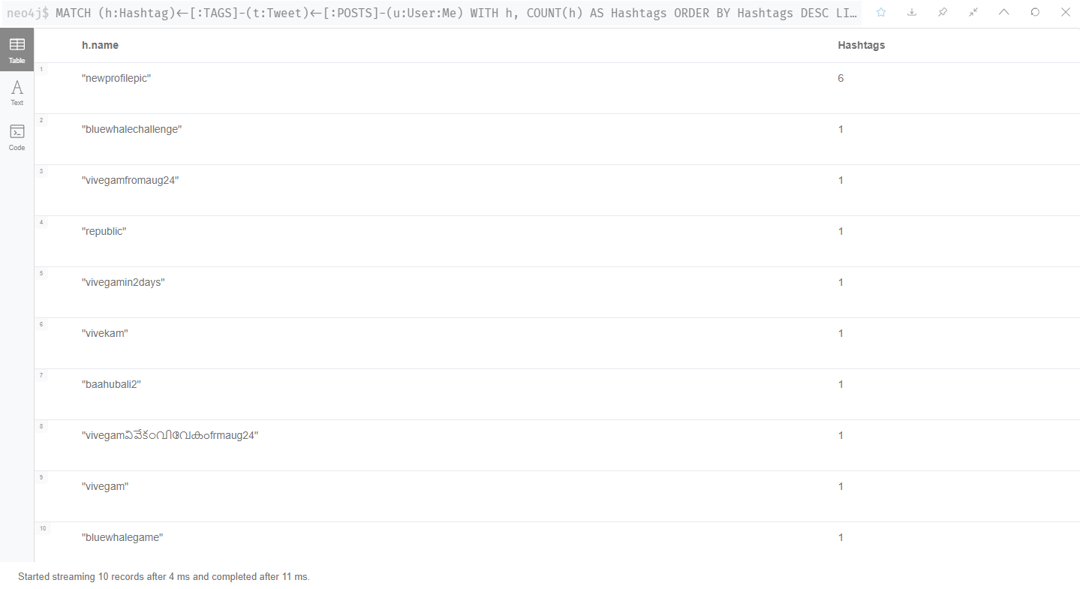

**7. Calculate the follow back rate :**

// Followback rate

MATCH

(me:User:Me)-[:FOLLOWS]->(f)

WITH

me, f, size((f)-[:FOLLOWS]->(me)) as doesFollowBack

RETURN

SUM(doesFollowBack) / toFloat(COUNT(f)) AS followBackRate

**OUTPUT:**

